134' Mini OSV
built 2003

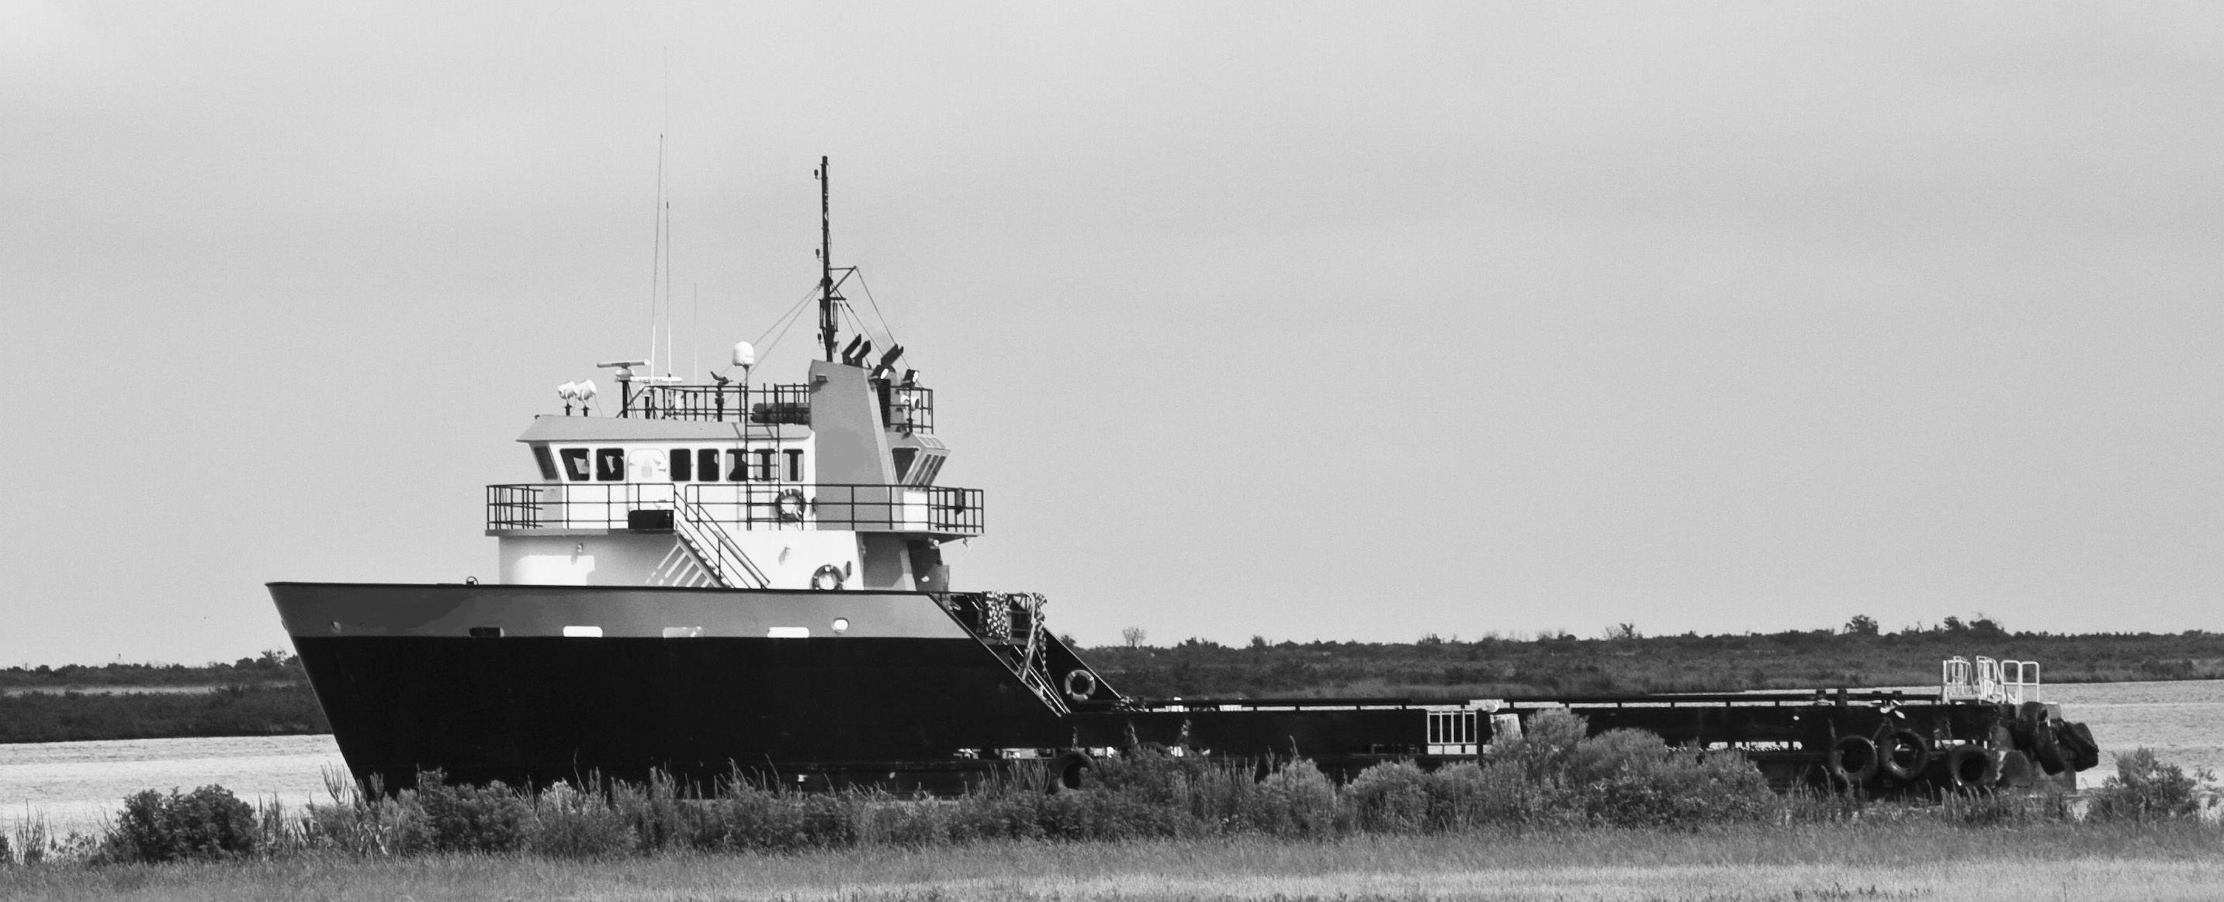

CHARACTERISTICS: CAPACITIES:
TYPE Supply FUEL OIL 53,000 gallons
GROSS TONS 99 LUBE OIL 800 gallons
NET TONS under 100 BALLAST WATER 99,500 gallons
YEAR BUILT 2003 POTABLE WATER 14,000 gallons
ABS LOADLINE yes DIRTY OIL 800 gallons
USCG INSP yes SEWAGE 1,200 gallons

DIMENSIONS: ACCOMODATIONS:
LENGTH 134’ CERTIFIED TO CARRY 20
BEAM 34’ BERTHS 20
DEPTH 12’6” WALK IN COOLER yes
CLEAR DECK 78’ x 27’ A/C & HEATING yes

PROPULSIONS: GENERATORS:
MAIN ENGINES CAT TWO (2) 99 Kw CAT 3304T
MODEL 3412 VOLTAGE 240/480 volts
STEERING Hydraulic
REDUCTION GEAR Twin disc ELECTRONICS:
STERN CONTROLS yes RADAR Two
SPEED 13 knots RADIOS 2 VHF/1 SSB
BOW THRUSTER yes FATHOMETER yes
GPS yes
MISC:
FIRE MONITOR yes
ANCHOR WINDLASS yes
ANCHO R 1000 #

(All details and specifications as per Owner and not guaranteed by Broker.)

